8 January 2011 Last updated at 00:35

**BBC**

**Obesity linked to money insecurity in affluent nations**

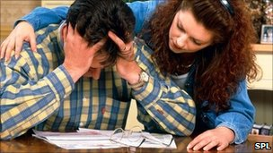

People in wealthy countries with "free market" economies are more likely to become obese, an Oxford University study says.

Money stresses in countries like the UK and US could explain their higher obesity levels, compared with countries such as Norway and Sweden.

The study, in Economic and Human Biology, compared obesity in 11 affluent countries from 1994 to 2004.

The researchers said the study showed obesity had "social causes".

Researchers set out to discover why Americans and Britons are heavier than Norwegians and Swedes.

Taking into account research into animal behaviour which shows that animals increase their food intake when faced with uncertainty, the Oxford researchers believed that stress could be a factor in causing people to overeat.

So they analysed data on obesity levels using 96 national surveys carried out over 10 years across a number of different countries.

They looked at 'market-liberal' countries including the US, UK, Canada and Australia.

These were compared with Finland, France, Germany, Italy, Norway, Spain and Sweden - which traditionally offer stronger social protection and higher levels of economic security.

**“**The economic benefits of flexible and open markets come at a price to personal and public health.” - End Quote Professor Avner Offer Oxford University

The study found that the more market-liberal countries stand out as having high levels of obesity - one-third more obesity on average - and higher rates of obesity growth.

This is true even when compared with other affluent countries with similar levels of incomes, the study says.

Social causes

The USA had the highest levels of obesity (with a mean of around 30% obese), whereas Italy, with the lowest prevalence, had almost half the levels (around 17%).

Professor Avner Offer, lead study author and professor of economic history at the University of Oxford, said: "Policies to reduce levels of obesity tend to focus on encouraging people to look after themselves but this study suggests that obesity has larger social causes.

"The onset and increase of large-scale obesity began during the 1980s, and coincided with the rise of market-liberalism in the English-speaking countries.

"It may be that the economic benefits of flexible and open markets come at a price to personal and public health which is rarely taken into account.

Professor Offer explained that market-liberal reforms have created more competition in some societies, and this has also undermined personal stability and security.

"It suggests that the economic benefits of flexible and open markets, such as they are, may be offset by costs to personal and public health which are rarely taken into account."

**REUTERS**

**Study suggests economic insecurity boosts obesity**

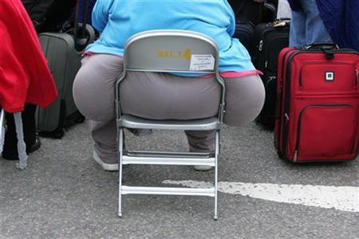

A passenger waits for a delayed flight at Heathrow airport's terminal four in London August 12, 2006.

Credit: Reuters/Toby Melville/Files

By [Kate Kelland](http://blogs.reuters.com/search/journalist.php?edition=uk&n=kate.kelland&)

LONDON | Fri Jan 7, 2011 2:42pm GMT

LONDON (Reuters Life!) –

The stress of being exposed to economic insecurity may mean people living in countries with so-called "free market" economies are more likely to become obese, British researchers said on Friday.

In a study in the journal Economics and Human Biology, Oxford University researchers found that Americans and Britons are much more likely to be obese than Norwegians and Swedes, and suggested that the stress of life in a competitive social system without a strong welfare state may cause people to overeat.

"Policies to reduce levels of obesity tend to focus on encouraging people to look after themselves, but this study suggests that obesity has larger social causes," said Avner Offer, a professor of economic history who led the study.

"It may be that the economic benefits of flexible and open markets come at a price to personal and public health which is rarely taken into account."

Offer's team looked at 11 wealthy countries and found that those with a liberal market regime -- with strong market incentives and relatively weak welfare states -- experienced one-third more obesity on average.

Comparing four "market-liberal" English-speaking countries -- the United States, Britain, Canada and Australia -- with seven relatively wealthy European countries that traditionally offer stronger social protection -- Finland, [France](http://uk.reuters.com/places/france), Germany, Italy, Norway, Spain and Sweden -- the team found that economic insecurity is strongly linked to levels of obesity.

Countries with higher levels of job and income security were associated with lower levels of obesity, the researchers said.

"Basically, our hypothesis is that market-liberal reforms have stimulated competition in both the work environment and in what we consume, and this has undermined personal stability and security," Offer said in a statement about the findings.

He also argued that the onset and increase of large-scale obesity began during the 1980s, coinciding with the rise of market-liberalism in the English-speaking countries.

The rise of obesity in wealthy societies has often been attributed to an increasingly ready supply of cheap, accessible, high-energy, pre-processed food in fast food outlets and supermarkets -- a phenomenon known as the "fast food shock" -- but Offer's team found that economic influences were greater.

The team measured fast food's impact by using a price index created by The Economist magazine which shows international variations in the cost of a McDonald's Big Mac hamburger.

They calculated that the availability of fast food had only about half as much of an effect on the prevalence of obesity as the effects of economic insecurity.

"The most powerful influence we have uncovered on levels of obesity is insecurity," they wrote in their study.

The researchers said they had only examined data at a national level and were now looking at data at an individual level to try to establish what drives people to overeat.

(Editing by [Paul Casciato](http://blogs.reuters.com/search/journalist.php?edition=uk&n=paul.casciato&))